Exhibitor-Sponsor Prospectus
2026 Annual Statewide Conference and Awards Ceremony
July 30-31, 2026
Marriott Columbus Northwest
5605 Blazer Parkway, Dublin, OH 43017
Application and Payment Deadline: Friday, June 1, 2026

Dear Potential Exhibitor and/or Sponsor,

The Ohio Chapter of the National Association of Pediatric Nurse Practitioners (NAPNAP) invites you to join us as an exhibitor and/or sponsor at our 2026 Annual Statewide Conference and Awards Ceremony, to be held July 30-31, 2026, at the Columbus Marriott Northwest in Dublin, Ohio. We value our exhibitors and sponsors as essential partners in making this annual event a success and welcome the opportunity to collaborate on an exhibitor and sponsorship experience tailored to your company’s or organization’s strategic goals.

To learn more about our annual conference, including program schedule, hotel accommodations, and shipping-receiving procedures, please visit Ohio NAPNAP’s website: Annual Statewide Conference and Become Our Event Partner. If you have any questions or need assistance in planning your participation, please contact us (via our website) or email us at info@ohionapnap.org.

Thank you for your interest in the exhibiting, sponsorship, and advertising opportunities for promoting your products and services at our upcoming event. We look forward to working with you!

Ohio Chapter of the National Association of Pediatric Nurse Practitioners
www.ohionapnap.org

About the Ohio Chapter of NAPNAP
The Ohio Chapter is the founding and largest state chapter of NAPNAP, representing more than 400 members across the state. Since 1973, NAPNAP has been a national leader, advancing the health of infants, children, adolescents, and young adults. We are committed to sustaining a strong, active organization that leads efforts to improve the quality of pediatric health care throughout Ohio. Our chapter supports members and pediatric-focused professionals through education, leadership, networking, and advocacy – empowering pediatric experts to improve child health outcomes statewide and beyond. We achieve this by promoting and supporting professional development; advocating for pediatric patients and the nursing profession; and fostering collaboration among providers, educators, researchers, and leaders in pediatric health.

- Our Vision: All children deserve quality health care and the opportunity to grow and thrive in a safe, supportive environment.
- Our Mission: To optimize pediatric health and empower a community of pediatric experts.

About Our Members and Conference Attendees
Our annual conference brings together pediatric nurse practitioners and other pediatric-focused professionals from across Ohio, including family nurse practitioners, clinical nurse specialists, nurse leaders, educators, and researchers with advanced education and training. Attendees work in a variety of settings – hospitals, primary care offices, specialty and community health clinics, schools, and academic institutions – and provide evidence-based care to infants, children, adolescents, and young adults. Many serve as key decision-makers in health care delivery, education, and research, and are strong advocates for pediatric patients and their families. This conference offers a unique opportunity to connect with highly engaged, influential pediatric providers and leaders who are actively shaping the future of pediatric care in Ohio and beyond.

Geographic Distribution of Members: Ohio Chapter
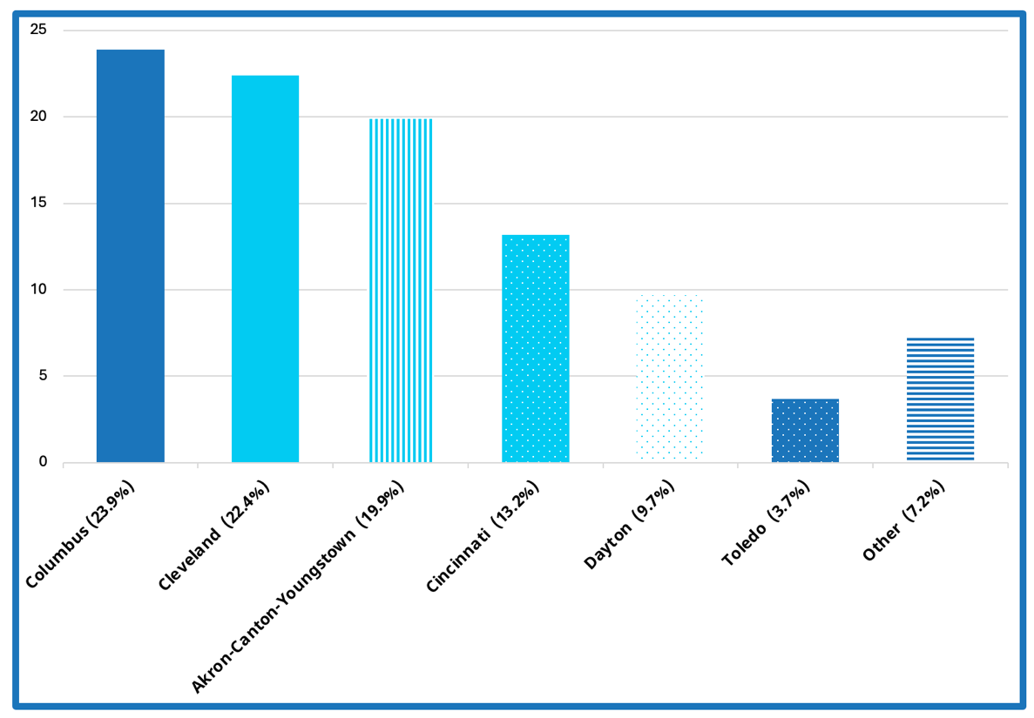
Note. This figure depicts major regions in Ohio where our members are located as of April 6, 2025.
“Other” represents members, including student members, who reside outside of Ohio.

Sponsorship and Exhibitor Opportunities
We invited you to participate in our 2026 Annual Statewide Conference through a variety of sponsorship and exhibitor options (see Exhibitor-Sponsorship Levels). Sponsors and exhibitors may receive exhibit access, promotional opportunities, and dedicated time with attendees during scheduled breaks – in accordance with NAPNAP’s Continuing Education Guidelines and the Pharmaceutical Research and Manufacturers of America (PhRMA) Code on Interactions With Healthcare Professionals. Additional sponsorship opportunities are available, including support for speakers, meals, and refreshment breaks.

Letter of Request, W-9 Form, and Conference Agenda
If you require a letter of request or a copy of our W-9 form, please contact us (via our website) or email us directly at info@ohionapnap.org. The conference agenda is available via our conference webpage.

Exhibitor-Sponsorship Levels

Level 1  Premier Partner  $5,000+ | Level 2  Signature Exhibitor-Sponsor  $2,500 | Level 3  Supporting Exhibitor-Sponsor  $1,500 | Level 4  Virtual Ally or Nonprofit  $500
- Two-Day Exhibit Opportunity: Connect with nurse practitioners and pediatric-focused professionals from across Ohio by showcasing your products or services at our in-person conference.  - Premium-Sized Exhibit Space: Up to three (3) exhibit tables (upon advanced request), including one 6-foot exhibit table with the option to add up to two additional tables (includes table drape, chairs, and trashcan).  - Prime Exhibit Location: Exhibit table(s) placed in a high-traffic, dedicated exhibit area to provide maximum visibility and accessibility.  - Inclusion in Conference Swag Bag: Opportunity to include full-size or larger promotional items and up to three (3) printed inserts in attendee conference bags.  - Access to Targeted Attendee List: Receive a list of attendees who opt-in for pre- and post-conference outreach.  - Participation in Exhibit Traffic-Building Activity: Engage with attendees through a fun, conference-wide incentive designed to boost exhibit traffic.  - On-Site Verbal Acknowledgment and Appreciation: Receive three (3) real-time, onsite verbal recognition announcements during the conference.  - Enhanced Logo Visibility: Larger logo featured in both the digital and printed conference program, accessible to all attendees.  - Extended Website Recognition: Your logo (linked to your website) will be displayed on the Ohio NAPNAP website and official conference webpage before, during, and for twelve (12) months after the conference.  - Enhanced Newsletter Exposure: Receive a dedicated full-page, full-color ad featured in three (3) Ohio NAPNAP newsletters (pre- and post-conference):  - Maximum Ad Size: 8.5” x 11”  (standard letter size).  Additional Perks:  - Speaking Opportunity (upon advance request): One member of your exhibit team may briefly promote your company (up to 5 minutes) during the conference’s opening or closing session.  - Social Media Recognition: Your company or organization will receive featured mentions on Ohio NAPNAP’s social media platforms before, during, and after the conference.  - Complementary Meals and Beverages for Exhibit Team (upon advance request): Up to ten (10) exhibit team members will receive complimentary meals (e.g., breakfast, lunch, dinner, snacks) and non-alcoholic beverages throughout the two-day conference.  - One Complementary Two-Day Conference Registration (upon advance request): One (1) exhibit team member may attend the full conference (Thursday and Friday).  Pre-registration is required by the stated deadline; on-site registration will not be available. A complimentary registration code will be provided upon request. | - Two-Day Exhibit Opportunity: Connect with nurse practitioners and pediatric-focused professionals from across Ohio by showcasing your products or services at our in-person conference.  - Double-Sized Exhibit Space: Up to two (2) exhibit tables (upon advanced request), including one 6-foot exhibit table with the option to add one additional table (includes table drape, chairs, and trashcan).  - Better Exhibit Location: Exhibit table(s) placed for strong visibility and convenient accessibility within the dedicated exhibit area (based on availability).  - Inclusion in Conference Swag Bag: Opportunity to include sample size promotional items and up to two (2) printed inserts in attendee conference bags.  - Access to Targeted Attendee List: Receive a list of attendees who opt-in for post-conference outreach.  - Participation in Exhibit Traffic-Building Activity: Engage with attendees through a fun, conference-wide incentive designed to boost exhibit traffic.  - On-Site Verbal Acknowledgment and Appreciation: Receive one (1) real-time, onsite verbal recognition during the conference.  - Logo Visibility: Your logo will be featured in both the digital and printed conference program, accessible to all attendees.  - Website Recognition: Your logo (linked to your website) will be displayed on the Ohio NAPNAP website and official conference webpage before, during, and for six (6) months after the conference.  - Additional Newsletter Exposure: Receive a half-page, full-color ad featured in two (2) Ohio NAPNAP newsletters (pre- and post-conference).  - Maximum Ad Size: 8.5” x 5.5”  (half of a standard letter size).  Additional Perks:  - Complementary Meals and Beverages for Exhibit Team (upon advance request): Up to five (5) exhibit team members will receive complimentary meals (e.g., breakfast, lunch, dinner, snacks) and non-alcoholic beverages throughout the two-day conference.  - One Complementary One-Day Conference Registration (upon advance request): One (1) exhibit team member may attend the conference (Friday only).  Pre-registration is required by the stated deadline; on-site registration will not be available. A complimentary registration code will be provided upon request. | - One-Day Exhibit Opportunity: Connect with nurse practitioners and pediatric-focused professionals from across Ohio by showcasing your products or services at our in-person conference.  - Standard Exhibit Location: Exhibit table located in dedicated exhibit area.  - Standard Exhibit Space: One (1) exhibit table (includes 6-foot table, table drape, chairs, and trashcan).  - Inclusion in Conference Swag Bag: Opportunity to include one (1) printed insert in attendee conference bags.  - Participation in Exhibit Traffic-Building Activity: Engage with attendees through a fun, conference-wide incentive designed to boost exhibit traffic.  - Acknowledgment and Appreciation: Your company or organization’s name will be featured alongside other exhibitors and sponsors in the digital conference program, on the Ohio NAPNAP website, and on the official conference webpage before, during, and for three (3) months after the conference.  - Standard Newsletter Exposure: Your company or organization’s name (without logo) will appear alongside other exhibitors and sponsors in one (1) Ohio NAPNAP newsletter (post-conference).  Additional Perks:  - Complementary Meals and Beverages for Exhibit Team (upon advance request): Up to two (2) exhibit team members will receive complimentary meals (e.g., breakfast, lunch, snacks) and non-alcoholic beverages throughout the one-day conference. | - Inclusion in Conference Swag Bag: Opportunity to include sample-size promotional items and up to two (2) printed inserts in attendee conference bags.  - Acknowledgment and Appreciation: Your company or organization’s name (without logo) will appear alongside other exhibitors and sponsors in the digital conference program, on the Ohio NAPNAP website, and on the official conference webpage before, during, and for three (3) months after the conference.  - Standard Newsletter Exposure: Your company or organization’s name (without logo) will appear alongside other exhibitors and sponsors in one (1) Ohio NAPNAP newsletter (post-conference).  Virtual Sponsor Only: This level does not include an exhibit table or any in-person opportunities.  Nonprofit Exhibitor Only: Includes all benefits listed under Level 3 (Supporting Exhibitor-Sponsor), with the following exception:  - Complimentary Meals and Beverages for Exhibit Team Member (upon advance request): One (1) exhibit team member will receive complimentary meals (e.g., breakfast, lunch, snacks) and non-alcoholic beverages throughout the one-day conference.
Additional Sponsorship Opportunities
All additional sponsorship opportunities will receive promotional visibility and other benefits based on their support level, ranging from those outlined in Level 1 (Premier Partner) to Level 4 (Virtual Ally). Please contact us (via our website) or email us info@ohionapnap.org to explore available options and discuss specific benefits and pricing. Sponsorship benefits may include inclusion in conference swag bags, access to targeted attendee list, and acknowledgment and recognition through our website, conference program materials, and newsletter.

Conference Swag Bags
Exclusive Sponsor: $1,000 (limited to one (1) sponsor)
Co-Sponsor: $500 (minimum of two (2) co-sponsors required)
Each attendee will receive a reusable bag to carry materials throughout the conference. The bags will feature your company’s or organization’s logo alongside the Ohio Chapter’s logo, and in the case of co-sponsorship, all participating sponsor logos will be included – providing extended visibility both during and after the event. Please note: The co-sponsor option will only be available if there is a minimum commitment of two sponsors. If that threshold is not met, we will contact you to discuss alternate opportunities or issue a refund.

Conference Speaker: Price Varies*
Help bring expert voices and educational content to our conference by sponsoring a speaker’s podium presentation. Contact us directly to explore available options and discuss specific benefits and pricing.
*Based on availability (usually reserved for Level 1 (Premier Partner) exhibitors and sponsors).

Conference Meal Packages: Price Varies
Gain visibility by sponsoring a conference meal. Sponsors will be recognized with on-site signage and program mentions as key contributors to this well-loved aspect of the event. Available sponsorship opportunities include:
- Dinner (Thursday, July 30, 2026).
- Dessert (Awards Ceremony – Thursday, July 30, 2026).
- Breakfast (Friday, July 31, 2026).
- Lunch (Friday, July 31, 2026).

Refreshment Break Packages: Price Varies
Refreshments breaks are a favorite among our attendees! Sponsorship also includes recognition through signage at the refreshment station. Available sponsorship opportunities include:
- Morning Break (Friday, July 31, 2026).
- Afternoon Break (Friday, July 31, 2026).
- Beverage Packages: Half-Day/Full-Day (Thursday, July 30-Friday, July 31, 2026).

Technology Packages: Price Varies (Minimum: $500-$4,500)
Support conference connectivity and engagement by sponsoring technology, such as audiovisual equipment, on-site tech support, or WiFi access for attendees. Contact us directly to explore available options and pricing.

Terms and Conditions
Please review the following information carefully. By submitting this application as an exhibitor and/or sponsor, you acknowledge and agree to comply with these terms and conditions:
- Application and Acceptance: Opportunities are limited and available on a first-come, first-served basis. Ohio NAPNAP reserves the right to accept or reject any application at its sole discretion. Applications are evaluated based on alignment with the mission and goals of Ohio NAPNAP, the professional or educational value of the products and/or services, and space availability. A binding agreement is established upon Ohio NAPNAP’s acceptance of the application and full payment. Confirmation of acceptance will be sent via email within seven (7) days of receipt of application and payment. Please ensure emails from info@ohionapnap.org is not blocked by your spam filter or firewall.
- Payment: Full payment is required with your application and must be received by the stated deadline. Failure to provide payment by the deadline may result in loss of the opportunity. Accepted payment methods: Visa, Mastercard, American Express, and Discover, and Link (U.S. bank accounts). Check payments are also accepted. Contact Ohio NAPNAP at info@ohionapnap.org for mailing details.
- Exhibit Hours, Setup, and Breakdown: Exhibits will be placed in a high-traffic area near the main educational session space. Exhibitor activities must remain within their assigned space. Exhibit setup and breakdown times depend on your exhibitor-sponsorship level and are subject to change based on the final program schedule:
Thursday, July 30, 2026:
- Exhibitor Set-Up Hours: 4:00-5:00 p.m.
- Exhibit Hours: 5:00-8:00 p.m. (see program schedule).
- Exhibitor Breakdown Hours: 8:00-9:00 p.m.
Friday, July 31, 2026:
- Exhibitor Set-Up Hours: 6:00-7:00 a.m.
- Exhibit Hours: 7:00 a.m.-4:15 p.m. (see program schedule)
- Exhibitor Breakdown Hours: 4:15-5:15 p.m.
- Exhibit Space Materials, WiFi, and Shipping/Receiving: Exhibitors and sponsors will be provided with exhibit materials according to their respective exhibitor-sponsorship level, which may include the following: a minimum of one (1) 6-foot skirted table, two chairs, a trash can, and complimentary hotel WiFi access. Layout and location of exhibit spaces may be modified at the discretion of Ohio NAPNAP. Exhibitors and sponsors are responsible for all shipping and handling of materials and promotional items. To ensure inclusion in attendee conference bags, all items must be received no later than July 1, 2026.
- Logos and Promotional Ads: Logos and promotional advertisements must be high-resolution (300 dpi) and press-ready in PDF or JPG format. To ensure inclusion in the event’s promotional materials, including the conference program, newsletters, and other advertising, please submit all files by July 1, 2026, to info@ohionapnap.org.
- Exhibitors and sponsors must adhere to the PhRMA Code on Interactions With Healthcare Professionals.
- Any continuing education (CE) sponsorships must comply with NAPNAP’s Continuing Education Guidelines.
- Private functions during scheduled conference sessions or events are not permitted.
- Cancellation Policy: All exhibitor and sponsorship fees are non-refundable, including cancellations and no-shows. If the event is rescheduled or reformatted for any reason, payments will be retained and applied unless otherwise agreed. If the event is cancelled due to unforeseen circumstances (e.g., low registration, illness outbreak, and natural disasters), Ohio NAPNAP will determine an equitable refund based on incurred expenses and obligations.
- Liability and Insurance: Ohio NAPNAP, NAPNAP, Inc, and the Renaissance Columbus Westerville-Polaris Hotel are not responsible for damage, loss, or failure of materials to arrive. Exhibitors and sponsors must maintain insurance adequate to cover any liabilities or claims related to their participation and provide proof of coverage upon request.
- Communication and Contact: All communications will be directed to the primary contact listed on the application. Ohio NAPNAP will not correspond with additional representatives – please ensure your designated contact information is current and accurate. All attendee communications, including emails and mailings, referencing the conference must either: promote your presence at the event in advance, or serve as a follow-up to attendees after the conference.
Exhibitor-Sponsorship Agreement
2026 Annual Statewide Conference and Awards Ceremony
Application and Payment Deadline: Monday, June 1, 2026

I, ________________________________ (name of primary contact person), as an authorized representative of ________________________________________________ (name and address of company or organization), agree to exhibit and/or sponsor the 2026 Annual Statewide Conference of the Ohio Chapter of the National Association of Pediatric Nurse Practitioners (“Ohio NAPNAP”), to be held in-person at the Marriott Columbus Northwest Hotel located in Dublin, Ohio, as indicated below by the selected exhibitor-sponsorship level. I understand and agree that this agreement is with Ohio NAPNAP and not with the National Association of Pediatric Nurse Practitioners, Inc. I further agree to waive any and all claims against Ohio NAPNAP and the National Association of Pediatric Nurse Practitioners, Inc.

Exhibitor-Sponsorship Level
Please indicate the desired exhibitor-sponsorship level:

☐ Level 1 (Premier Partner): $5,000

☐ Level 2 (Signature Exhibitor-Sponsor): $2,500

☐ Level 3 (Supporting Exhibitor-Sponsor): $1,500

☐ Level 4 (Virtual Ally or Nonprofit): $500

☐ Additional Sponsorship: $ __________ (please describe additional sponsorship opportunity):

Exhibit Table Request
Please indicate the number of exhibit tables you are requesting, if applicable, based on your exhibitor or sponsorship level:

☐ 0 (zero) No Exhibit Table
Level 1 (Premier Partner): May request up to three (3) exhibit tables.
Level 2 (Signature Exhibitor-Sponsor): May request up to two (2) exhibit tables.
Level 3 (Supporting Exhibitor-Sponsor): May request up one (1) exhibit table.
Level 4 (Nonprofit): May request up one (1) exhibit table.
Level 4 (Virtual Ally): Not Applicable.

☐ 1 (one) Exhibit Table

☐ 2 (two) Exhibit Tables

☐ 3 (three) Exhibit Tables

☐ NA (not applicable)

Exhibit Team Meal Request
Please indicate the number of exhibit team members requesting complimentary meals and beverages, based on your exhibitor or sponsorship level. Kindly notify Ohio NAPNAP (info@ohionapnap.org) if any exhibit team members have dietary restrictions or food allergies.
Level 1 (Premier Partner): May request meals/beverages up to ten (10) exhibit team members.
Level 2 (Signature Exhibitor-Sponsor): May request meals/beverages up to five (5) exhibit team members.
Level 3 (Supporting Exhibitor-Sponsor): May request meals/beverages up to two (2) exhibit team members.
Level 4 (Nonprofit): May request meals/beverages up to one (1) exhibit team member.
Level 4 (Virtual Ally): Not Applicable.

Number of Exhibit Team Members Requesting Complimentary Meals and Beverages: _______________ (total number).

Exhibit Team Member Conference Registration Request*
Please indicate the number of complimentary conference registrations you are requesting, if applicable, based on your exhibitor or sponsorship level:
Level 1 (Premier Partner): One (1) complimentary two-day conference registration.
Level 2 (Signature Exhibitor-Sponsor): One (1) complimentary one-day conference registration.
Level 3 (Supporting Exhibitor-Sponsor): Not Applicable.
Level 4 (Virtual Ally or Nonprofit): Not Applicable.

☐ 0 (zero)

☐ 1 (one)

☐ NA (not applicable)

Name and Email Address of Exhibit Team Member: ______________________________________________________________________________________________________________________.
*Online registration is required by the stated deadline. Please contact Ohio NAPNAP (info@ohionapnap.org) to request a complimentary registration code.

Authorized Representative (Primary Contact Person):
I have read and agree to abide by the terms and conditions outlined above:

Name: ____________________________________________________________________________________________________

Email: ________________________________________________________ Telephone: ____________________________

Signature: ____________________________________________________ Date: ____________________________________

Payment
To submit your credit card payment, please select the appropriate link or scan the QR code corresponding to your chosen exhibitor-sponsorship level. Our Employer Identification Number (EIN) and mailing address for check payments are available upon request. If you have any questions or need assistance with payment, please do not hesitate to contact us.

Level 1 (Premier Partner): $5,000 Level 2 (Signature Exhibitor-Sponsor): $2,500
https://buy.stripe.com/aFa9AU5SY94cgbBaOz73G0o https://buy.stripe.com/6oUcN6chm1BK2kL8Gr73G0p

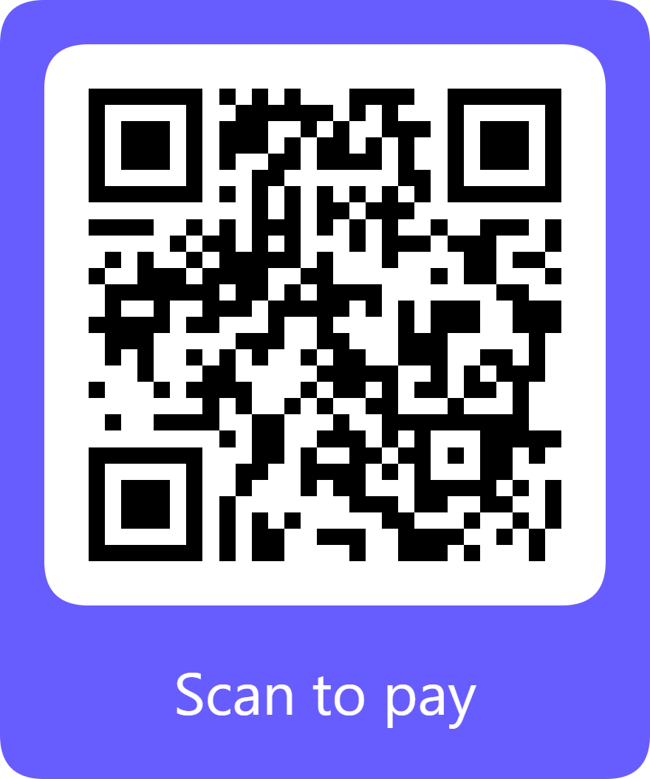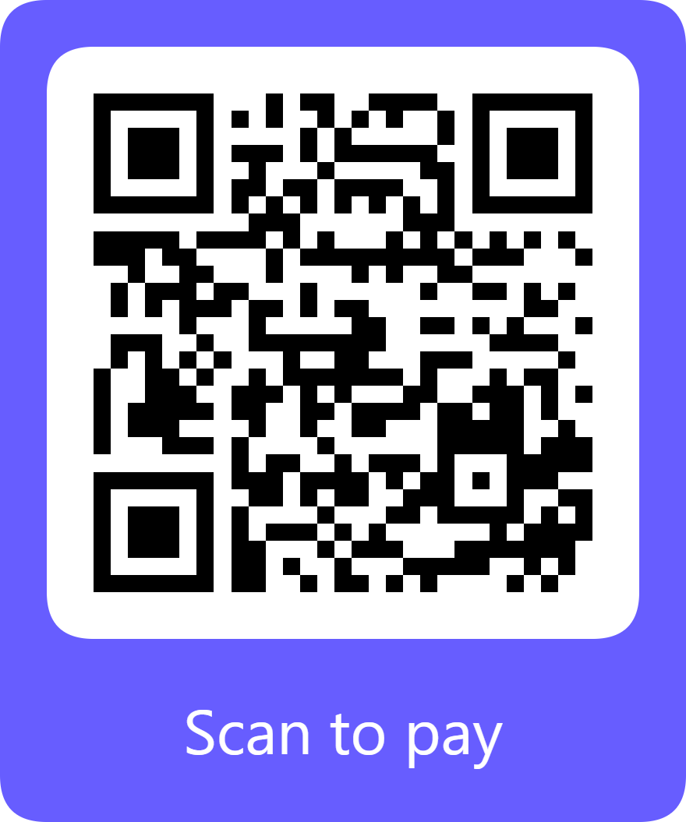

Level 3 (Supporting Exhibitor-Sponsor): $1,500 (Level 4 (Virtual Ally or Nonprofit): $500
https://buy.stripe.com/4gM5kE1CI2FObVl4qb73G0q https://buy.stripe.com/eVqeVe0yE6W41gH09V73G0r

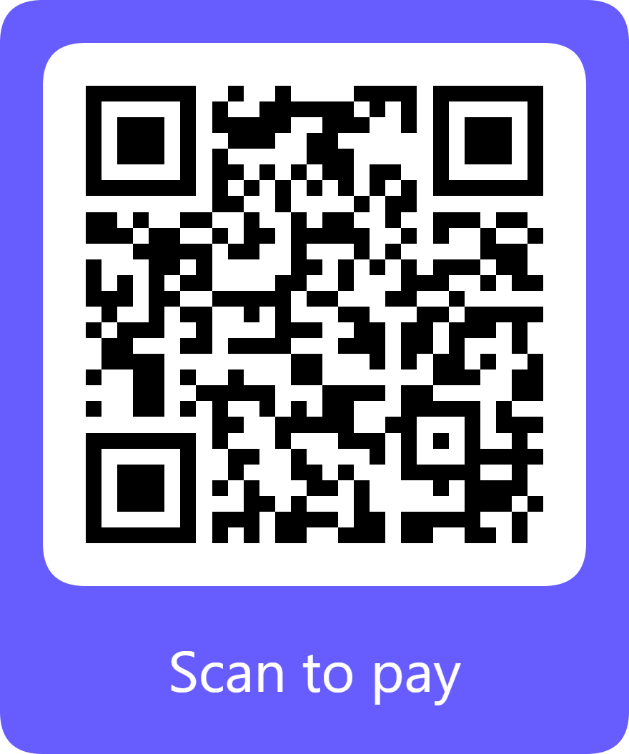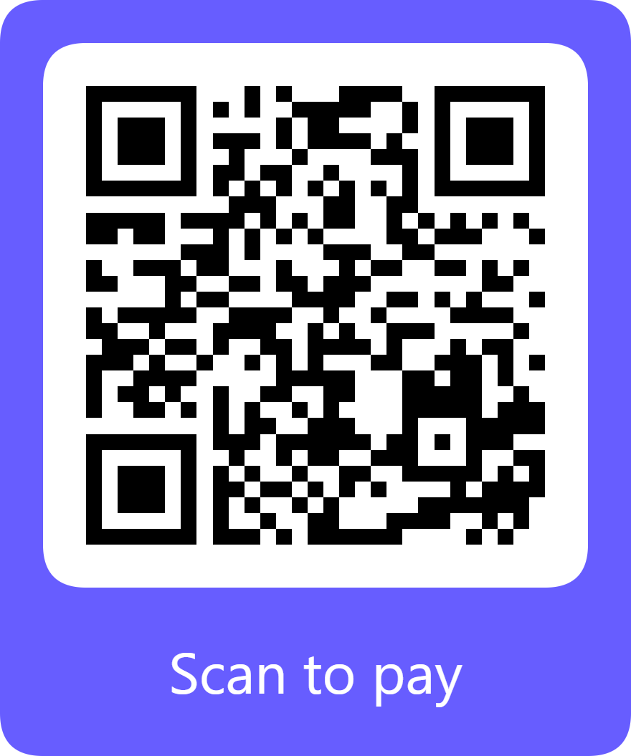

Additional Sponsorship Opportunity ACH Direct Debit Option
https://buy.stripe.com/aFacN63KQbckaRh5uf73G0s https://buy.stripe.com/fZu8wQa9efsA9Nde0L73G0v

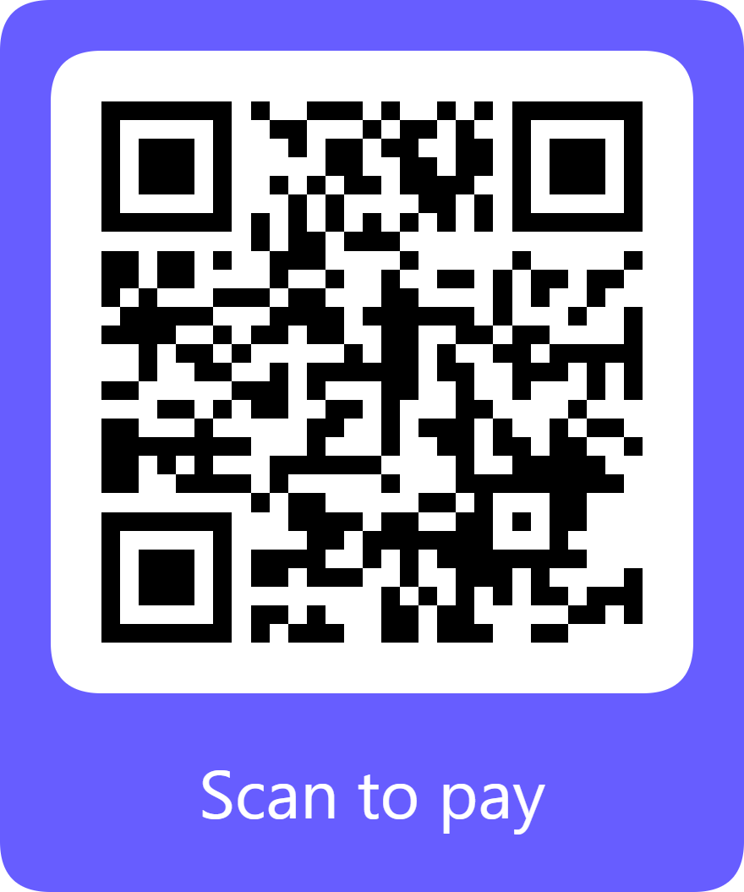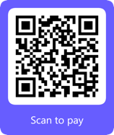

$____________ (please fill in the amount) Automated Clearing House (ACH) direct debit payment: To use this option, select the “Bank” payment method and manually enter the total dollar amount owed.

